Ex no: 11

Date:

**TRIGGER**

**AIM:**

To create a trigger in MY SQL to lot of changes for employee table.

1. **To create a table employees**

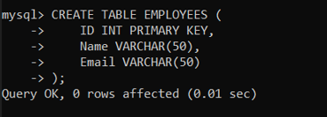

1. **To create table employees audit:**

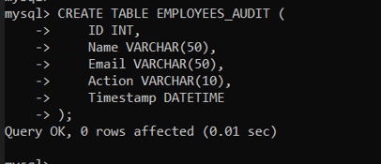

1. **Implement trigger function**

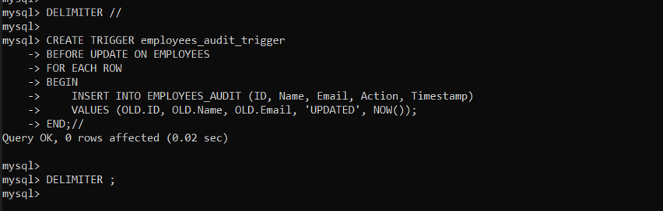

**Result:**

Trigger command is successfully implemented and executed.